**A Questionnaire about Metaverse for Software Engineering Students**

Huang Zi-han

(School of software, Nanchang Hangkong University, No.19205114)

**Abstract**

I prepared a questionnaire about Metaverse and analyzes people’s thoughts about Metaverse according to the results. In general, people are optimistic about the future of Metaverse.

**Introduction**

On October 29, 2021, Facebook announced changed its name to “Meta”, which caused a popular discuss on Metaverse. At the time, almost everyone talking about Metaverse.

I know very limited about it in the first time. I had watched a movie called Ready Player One and impressed by its virtual world, Oasis. Although the Oasis is more about the game players, it makes me feel the virtual world is achievable. And it is worth to be expected.

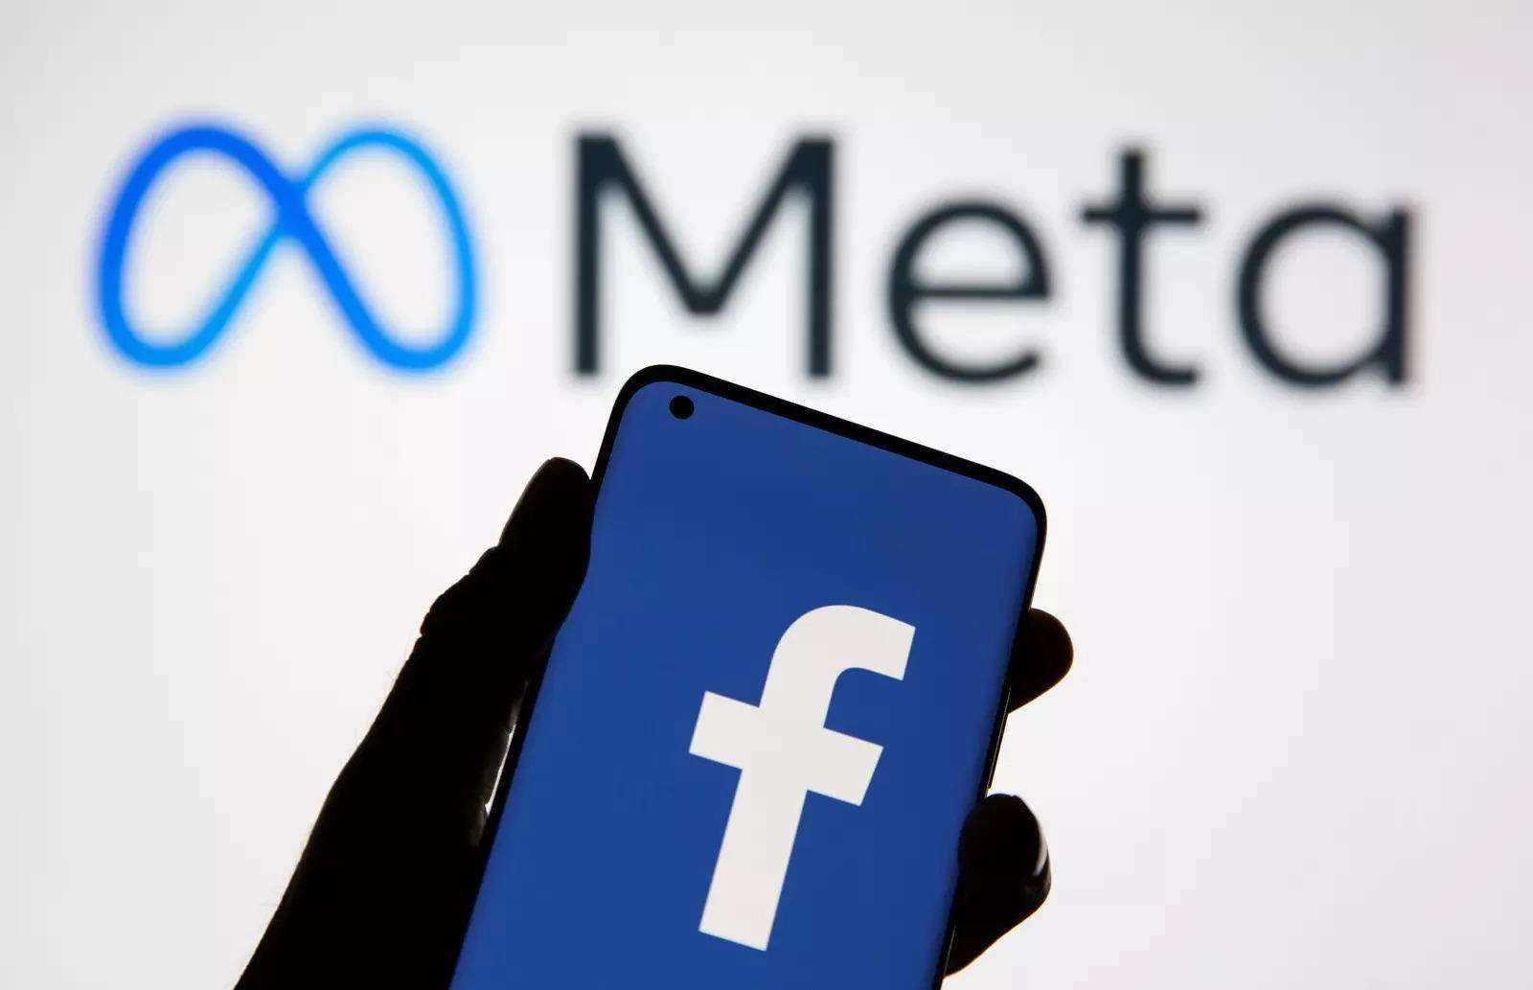

As a Software Engineering student, I’m very interested in Metaverse concepts, and I’m curious about what other students think about Metaverse. So I made a questionnaire investigation to do research.

**Methodology**

I prepared 6 questions about Metaverse, and list the corresponding options to select. We exchange our questionnaires by class. Each of them should complete all the questions raised by our class’s students. On the contrary, each of us should finish all the questions raised by another class’s students. And the results will be returned to questionnaire’s owner to do the next research.

**Result**

I had received 31 questionnaire results. And I sort out the results as follows.

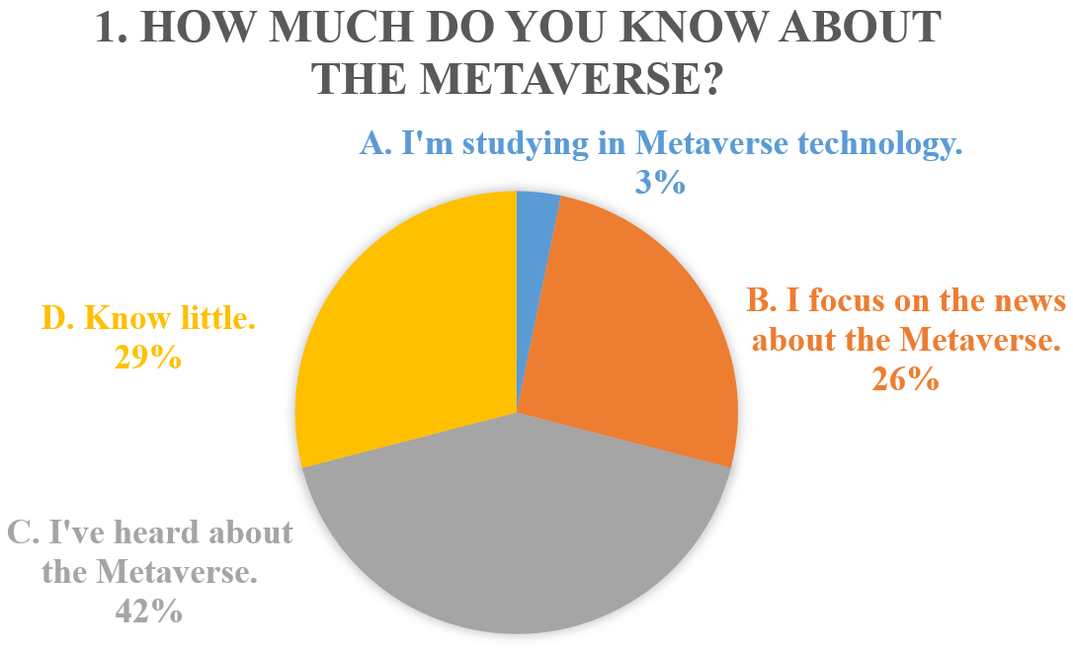

**Figure 1: How much do you know about the Metaverse? Most students choose “I’ve heard about the Metaverse”. And seldom students choose “I’m studying in Metaverse technology”.**

The first question is about people’s understanding of Metaverse. The result show that people have limited understanding of it. And we can guess that people are more affected by the news, because the Metaverse is exactly popular news in the recent. Also, there is a student choose “I’m studying in Metaverse technology”. It’s truly makes me wonder which field he is studying in Metaverse.

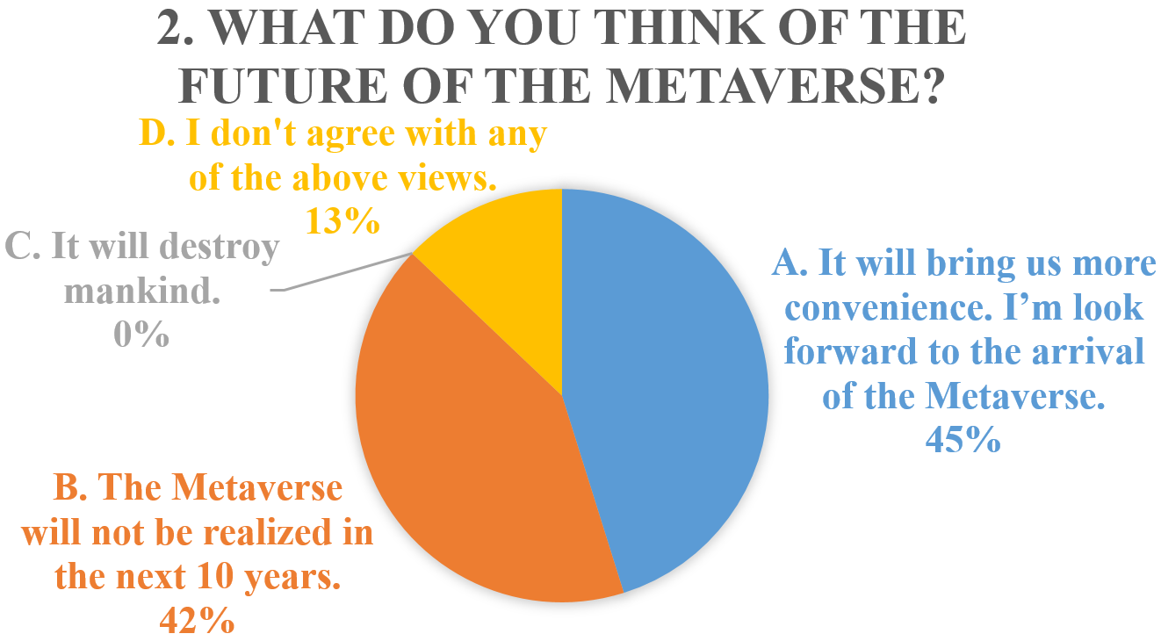

**Figure 2: What do you think of the future of the Metaverse? Most students choose “It will bring us more convenience. I’m look forward to the arrival of the Metaverse” and “The Metaverse will not be realized in the next 10 years”. Nobody choose “It will destroy mankind”.**

The second question is about the future of Metaverse. It is surprised to see that nobody choose “It will destroy mankind”, such a sad and desperate answer. And the optimistic and pessimistic views are almost half and half. And there are 4 students don't agree with any of the above views. Maybe they have more novel ideas about the future of Metaverse.

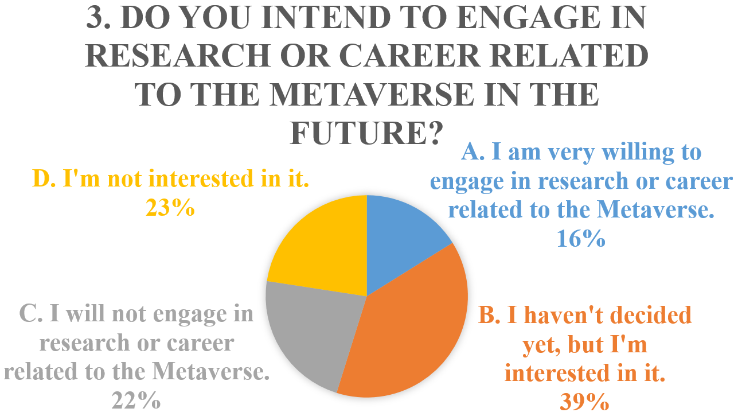

**Figure 3: Do you intend to engage in research or career related to the Metaverse in the future? Most students choose “I haven't decided yet, but I'm interested in it”.**

The third question is about their future career or study direction. Many students don’t make a firm decision because they don’t know Metaverse enough. But a good thing is they are interested in it. People’s curiosity will also promote the creation of the Metaverse.

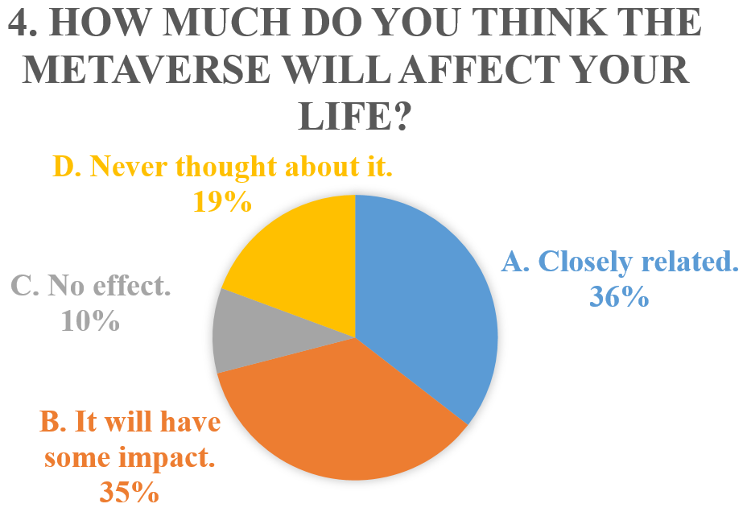

**Figure 4: How much do you think the Metaverse will affect your life? Lots of students think “Closely related” and “It will have some impact”.**

The fourth question is about how much the Metaverse will affect our daily life. “Anything existing must be reasonable”. We always have this idea. But still has lots of students choose “Closely related”. So people will agree that the Metaverse can affect our daily life closely. Our life has been changed greatly by the Internet, so do Metaverse in the future.

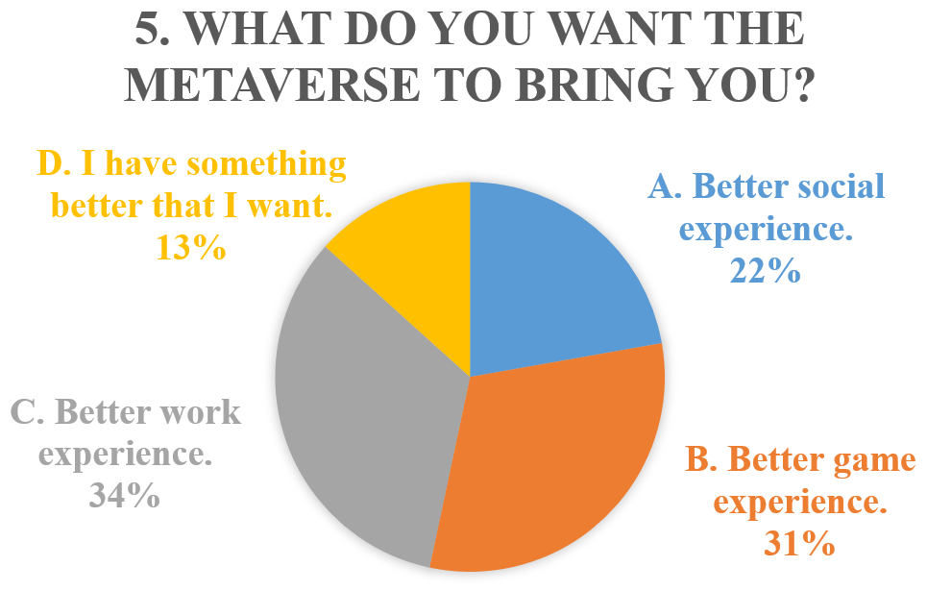

**Figure 5: What do you want the Metaverse to bring you? Most students choose “Better work experience”.**

The fifth question is about what do people want from Metaverse. Most students want to have a better working experience. This is quite surprising, after all there are better social and game experience you can choose. This is also shows that grade 3 students still concerned about their future working experience.

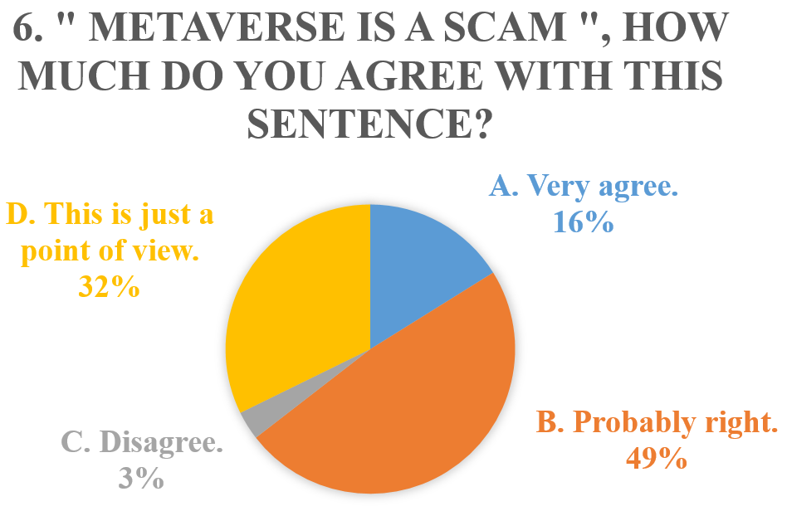

**Figure 6: “Metaverse is a scam”, how much do you agree with this sentence? Half of students choose “Probably right”.**

The sixth question is interesting. Many students still skeptical of the popular event, Metaverse. We know that Metaverse is popular by the news of the media. Students still have reservations about the development of the Metaverse. Also worried about information transmission power of the media.

**Conclusion**

According to the results of the questionnaire, people have limited understanding of Metaverse. But people have a good impression of it, and thinking that Metaverse will change our daily life in the future. And as students of Software Engineering, we are more concerned about the future working experience. Also, we are still skeptical of the development of Metaverse.

**Reference**

Wikipedia: Metaverse

[https://en.wikipedia.org/wiki/Metaverse]